

FirstName LastName

Job title in English | Job title in French
Department in English | Department in French
+41 22 123 45 67
+41 79 123 45 67
email@unitaid.who.int

unitaid.org
Follow us on: Facebook, Twitter / X, LinkedIn, Instagram, Bluesky and YouTube.

Step 1: Edit then copy the signature above
- Scroll to the top of this document and edit the signature with your own details.
- Select the entire signature (text, logos, icons).
- Copy it by pressing Ctrl + C or by right-clicking then clicking on “Copy”.
- Make sure no extra blank lines are included before or after the signature.

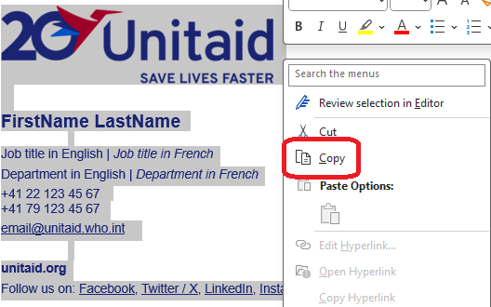

Step 2: Open Outlook
- Open Microsoft Outlook.
- Go to your Inbox (Mail view).

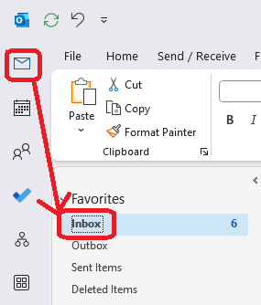

Step 3: Open signature settings
- Click File
- Click Options
- Select Mail
- Click Signatures…

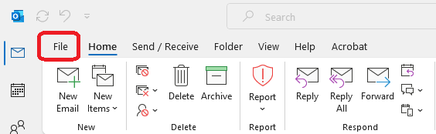

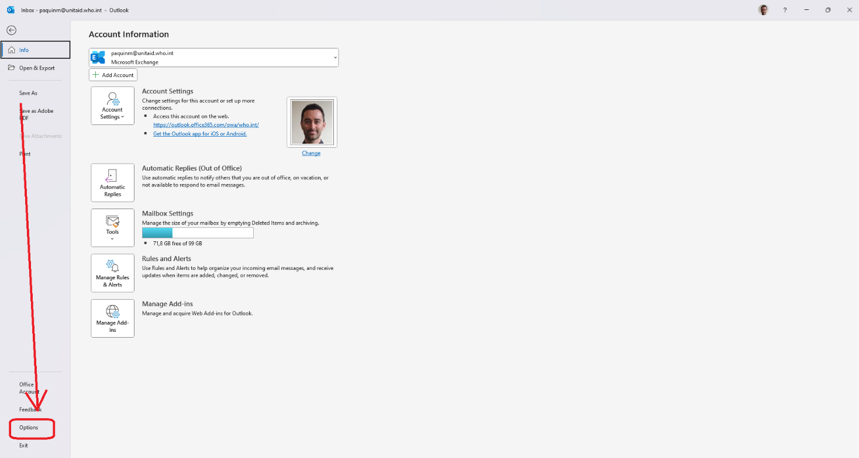

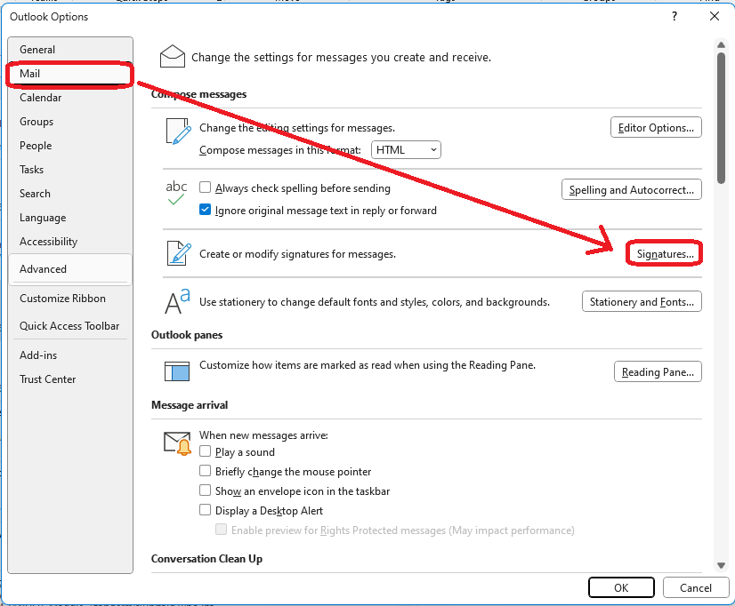

Step 4: Create a signature
- Click New to create a new signature.
- Name the signature (for example: Unitaid at 20) and click OK.
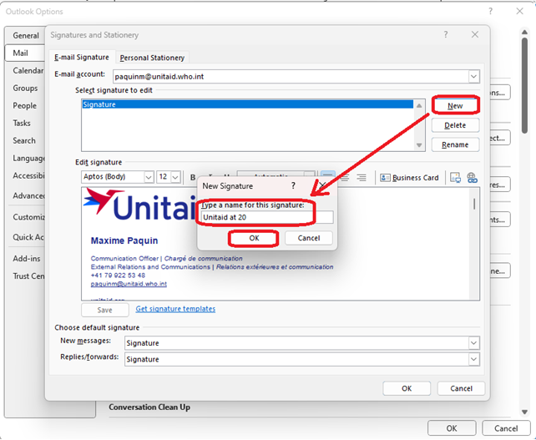

Step 5: Paste the Signature
- Click inside the signature editor box.
- Paste the copied signature using Ctrl + V.
- Confirm:
  - Text formatting appears correctly
  - Logos and icons are visible
  - Links are clickable
- Do not re-paste from another email, as this may break formatting.
- Choose the new signature you just created as the default signature for new messages and replies/forwards.
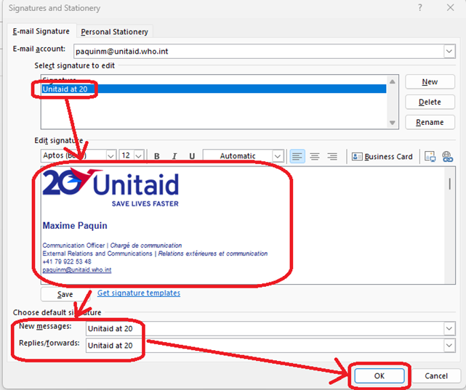

Step 6: Save and test
- Open a new email.
- Confirm the signature appears automatically. If it doesn’t select it from the “Signature” dropdown menu under the “Message” tab.
- Send a test email to yourself to verify formatting.

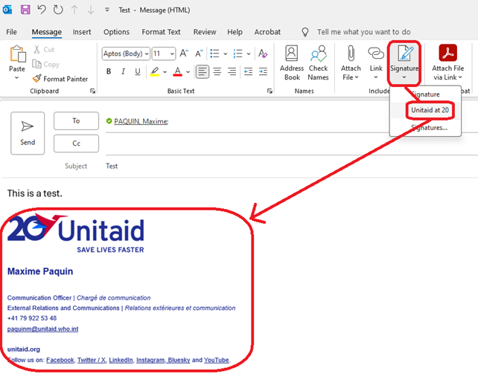

Verify the email you just sent yourself. If it looks like the example below, you are good to go!
