Email Signature Instructions
Download the word version to your computer
(you can’t use the web version for this purpose)
Chose a signature – located on the next page, highlight, and copy it
(Choose from Melbourne, Brisbane, Sydney locations or no location)
Open your Outlook app on PC (not web versions) select:
File > Options >Mail> Signatures and click + to add a signature.
or
Open your Outlook app on MAC (not web versions) select:
Preferences > Signatures and click + to add a signature.
Name your new signature Versent and then paste your copied signature.
Edit your name & Title.
Right click on the email address > Choose manage link settings > Edit.
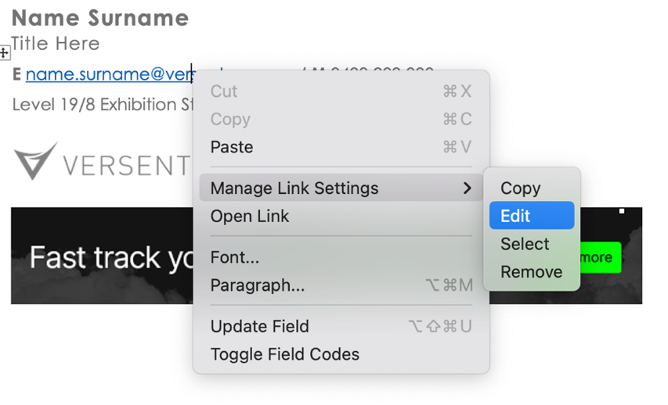
Enter your email address to both display & email address fields.
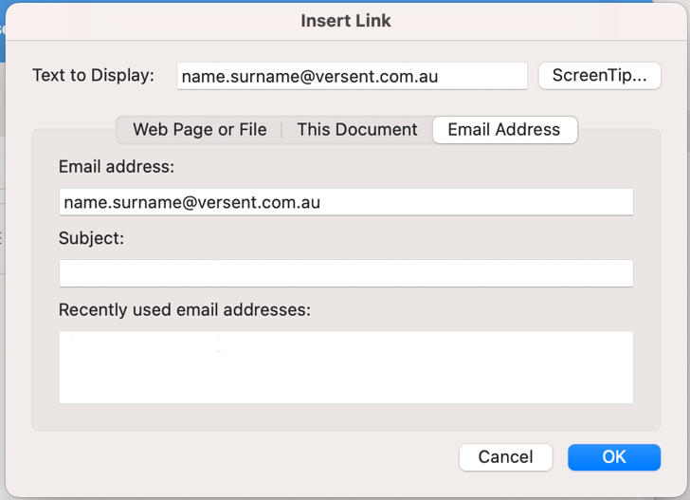
Click ok and then save.

Melbourne Signature
Name Surname
Title Here
E name.surname@versent.com.au / M 0400 000 000
Level 19/8 Exhibition Street, Melbourne, VIC 3000
 |  | 
This email may contain confidential information. If I've sent it to you by accident, please delete it immediately.

Brisbane Signature
Name Surname
Title Here
E name.surname@versent.com.au / M 0400 000 000
Level 4/275 George Street, Brisbane City, QLD 4000
This email may contain confidential information. If I've sent it to you by accident, please delete it immediately.

Adelaide Signature
Name Surname
Title Here
E name.surname@versent.com.au / M 0400 000 000
TechCentral Building, Lot 14, level 5, Frome Road,
Adelaide, SA 5000
This email may contain confidential information. If I've sent it to you by accident, please delete it immediately.

Perth Signature
Name Surname
Title Here
E name.surname@versent.com.au / M 0400 000 000
Level 17/125 St Georges Terrace, Perth, WA 6000
This email may contain confidential information. If I've sent it to you by accident, please delete it immediately.
Denver Signature
Name Surname
Title Here
E name.surname@versent.com.au / M 0400 000 000
1700 Lincoln St 17th Floor, Denver, CO 80203 USA
This email may contain confidential information. If I've sent it to you by accident, please delete it immediately.

Sydney Signature
Name Surname
Title Here
E name.surname@versent.com.au / M 0400 000 000
Level 11, 111 Elizabeth St, Sydney, NSW 2000
This email may contain confidential information. If I've sent it to you by accident, please delete it immediately.

No Location Signature
Name Surname
Title Here
E name.surname@versent.com.au / M 0400 000 000
This email may contain confidential information. If I've sent it to you by accident, please delete it immediately.

