**Email Signature Instructions**

**Please note:** (you can’t use the web version of outlook for this purpose) **Chose a signature – located on the next pages, highlight, and copy it**

**Open your Outlook app on PC** (not web versions) **select:  
File > Options >Mail> Signatures and click + to add a signature.**

or

**Open your Outlook app on MAC** (not web versions) **select:**  
**Preferences > Signatures and click + to add a signature.**

**Name your new signature Versent** and then paste your copied signature.

**Edit your name & Title.**

**Right click on the email address** > Choose manage link settings > Edit.

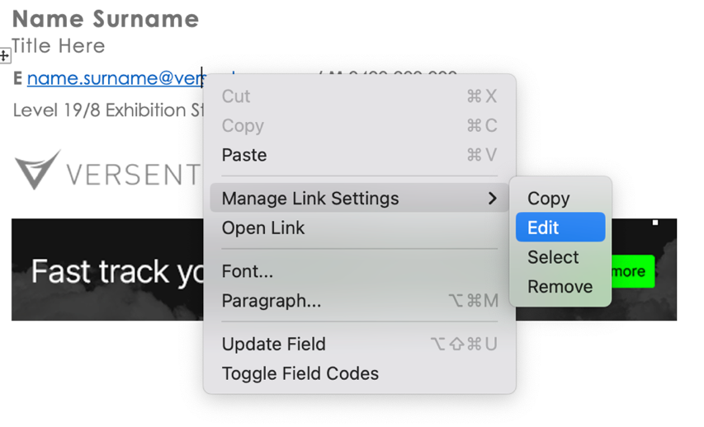

**Enter your email address** to both display & email address fields.

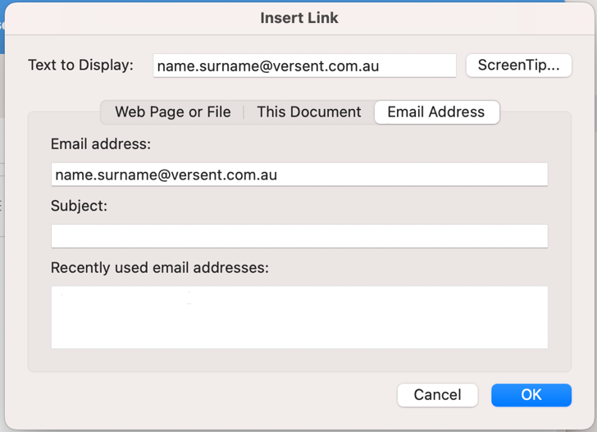

**Click ok and then save.**

**Name Surname**Title

|  |  |  |
| --- | --- | --- |
| **E** name.surname@versent.com.au / **M** 0400 000 000 | | |
|  |  |  |

This email may contain confidential information. If I've sent it to you by accident, please delete it immediately.

**Name Surname**Title

|  |  |  |  |
| --- | --- | --- | --- |
| **E** name.surname@versent.com.au / **M** 0400 000 000 | | | |
|  |  |  |

This email may contain confidential information. If I've sent it to you by accident, please delete it immediately.

**Name Surname**Title

|  |  |  |  |  |
| --- | --- | --- | --- | --- |
| **E** name.surname@versent.com.au / **M** 0400 000 000 | | | | |
|  |  |  |  |  | |

This email may contain confidential information. If I've sent it to you by accident, please delete it immediately.

**Name Surname**Title

|  |  |  |  |  |
| --- | --- | --- | --- | --- |
| **E** name.surname@versent.com.au / **M** 0400 000 000 | | | | |
|  |  |  |  |  | |

This email may contain confidential information. If I've sent it to you by accident, please delete it immediately.

**Name Surname**Title

|  |  |  |  |  |
| --- | --- | --- | --- | --- |
| **E** name.surname@versent.com.au / **M** 0400 000 000 | | | | |
|  |  |  |  |  | |

This email may contain confidential information. If I've sent it to you by accident, please delete it immediately.